**MINI-PROJECT REPORT**

Student Online

Voting System



# NAME: - Yelika Mounika

**TABLE OF CONTENTS**

|  |  |  |
| --- | --- | --- |
| **SERIAL No.** | **CONTENT** | **PAGE No.** |
| 1 | Introduction | 3 |
| 2 | Objective | 3 |
| 3 | Features | 3 |
| 4 | 4 W’s 1H | 4 |
| 5 | SWOT Analysis | 4 |
| 6 | Requirements | 6 |
| 7 | Architecture | 7 |
| 8 | Use case diagram | 8 |
| 9 | Expected results/Outcomes | 9 |

# Introduction :

In this project , we make a voting machine in which we have 4 different options to vote . Each user vote one time and after all the use gives their vote .

We will conclude the result and store in our life and we have a full-fledged file in which we store a winner party for every year .

The main aim of the project is to provide safe and secure voting system environment , where admin can allow the user to vote , and admin declare a result.

# Objective:

* The primary objective of student voting system is to provide safe and secure voting system.
* In this they can vote and select their Leader as per their choice .
* student voting system may be used in colleges / schools to select class representative or leader to college.

# Benefits:

With our lives increasingly shifting online , its only logical that voting would transition to a digital platform , too . Although public elections have yet to embrace such methods , many private organizations have eagerly adopted internet voting , enabling them to take advantage of significant benefits. We break down these features and explain their importance.

* Accessible & Easy to use
* Secure
* Accurate
* Increased Turnout and Engagement
* Reduced costs

# Features :

* Nominations Services
* Ballot Features
* Full Service Management
* Social Media Integration
* Tracking and Tabulation
* Security

# 4W’s H :

# Who:

This is everyone who is ready to manage the computer system in the online voting section and to proceed the function.

# What:

It enable your electorate to vote from anywhere in the world – without barriers. This allows everybody the chance to participate in student council elections very easily and conveniently. You will also save time and money that would other wise go towards the printing, distributing and counting of paper ballots by hand.

# Where:

Student councils enable pupils to participated democratically within their school. Choosing the right voting procedure in student council elections is crucial because the whole student body should be able to take part. It can help increase your voter turnout and give your election more legitimacy.

# How:

All you need to vote online is a device connected to the internet. As the election manager , you can decide how to make the electoral roll available, how voter information should be delivered and election results shuld be distributed.

All eligible voters receive a personal ID and a one-time password in order to cast their vote. With this data, students can access the online voting system through a secure two-step authentication process. After logging in to system , the online ballot will be displayed and voters can allocate their votes as they see fit.

# SWOT Analysis Strengths

* Reduce cost of voting.
* Voting in any language convenient to the voter.
* Tracking social, technical, political, legal and economic issues associated with elections.
* Provides efficient and fast means for votes counting.
* Relays messages associated to election fast.

# Weaknesses

* Difficult topographic terrain.
* Lack or pressure group in support of electronic voting system.
* Inadequate transparent mechanism which favors the existing electoral officials.
* Behavioral change and technology acceptance.
* Lack of constitutional positions in support of e-voting.

# Opportunities

Student councils enable pupils to participated democratically within their school. Choosing the right voting procedure in student council elections is crucial because the whole student body should be able to take part. It can help increase your voter turnout and give your election more legitimacy.

# Threats

* Computers are very complicated things and there is no way with any reasonable amount of resources that you can guarantee that the software and hard ware are bug-free and they haven’t been maliciously attacked.
* Compared to the touch screen voting machines , the opportunity for attacks on the internet is much broader.
* From that perspective , looking at a system that relies on the perfectibility of computers is a really bad idea.
* How easy would it be to hack a computerized system ? not very hard , as we can see from the frequent news stories about massive thefts of data from government and corporate web servers.
* And there are many other threats , including voters who are not experts in computer security and may be easily fooled , and potential for corrupt insiders at companies that produce the internet voting software.

# REQUIREMENTS:

**High Level Requirements:**

|  |  |  |
| --- | --- | --- |
| RID | Description | Status |
| HLR1 | C language | Implemented |
| HLR2 | OS windows | Implemented |
| HLR3 | OS Linux | Implemented |
| HLR4 | Hard disk | Implemented |

# Low Level Requirements :

|  |  |  |
| --- | --- | --- |
| RID | Description | Status |
| LLR1 | ADD Voter’s ID | Implemented |
| LLR2 | Take Vote’s from user’s | Implemented |
| LLR3 | Count no. of Votes | Implemented |
| LLR4 | Declare the result | Implemented |

**Architecture:**

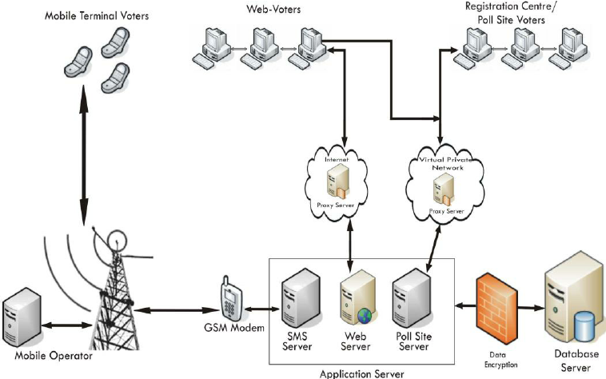

# Use Case Diagram

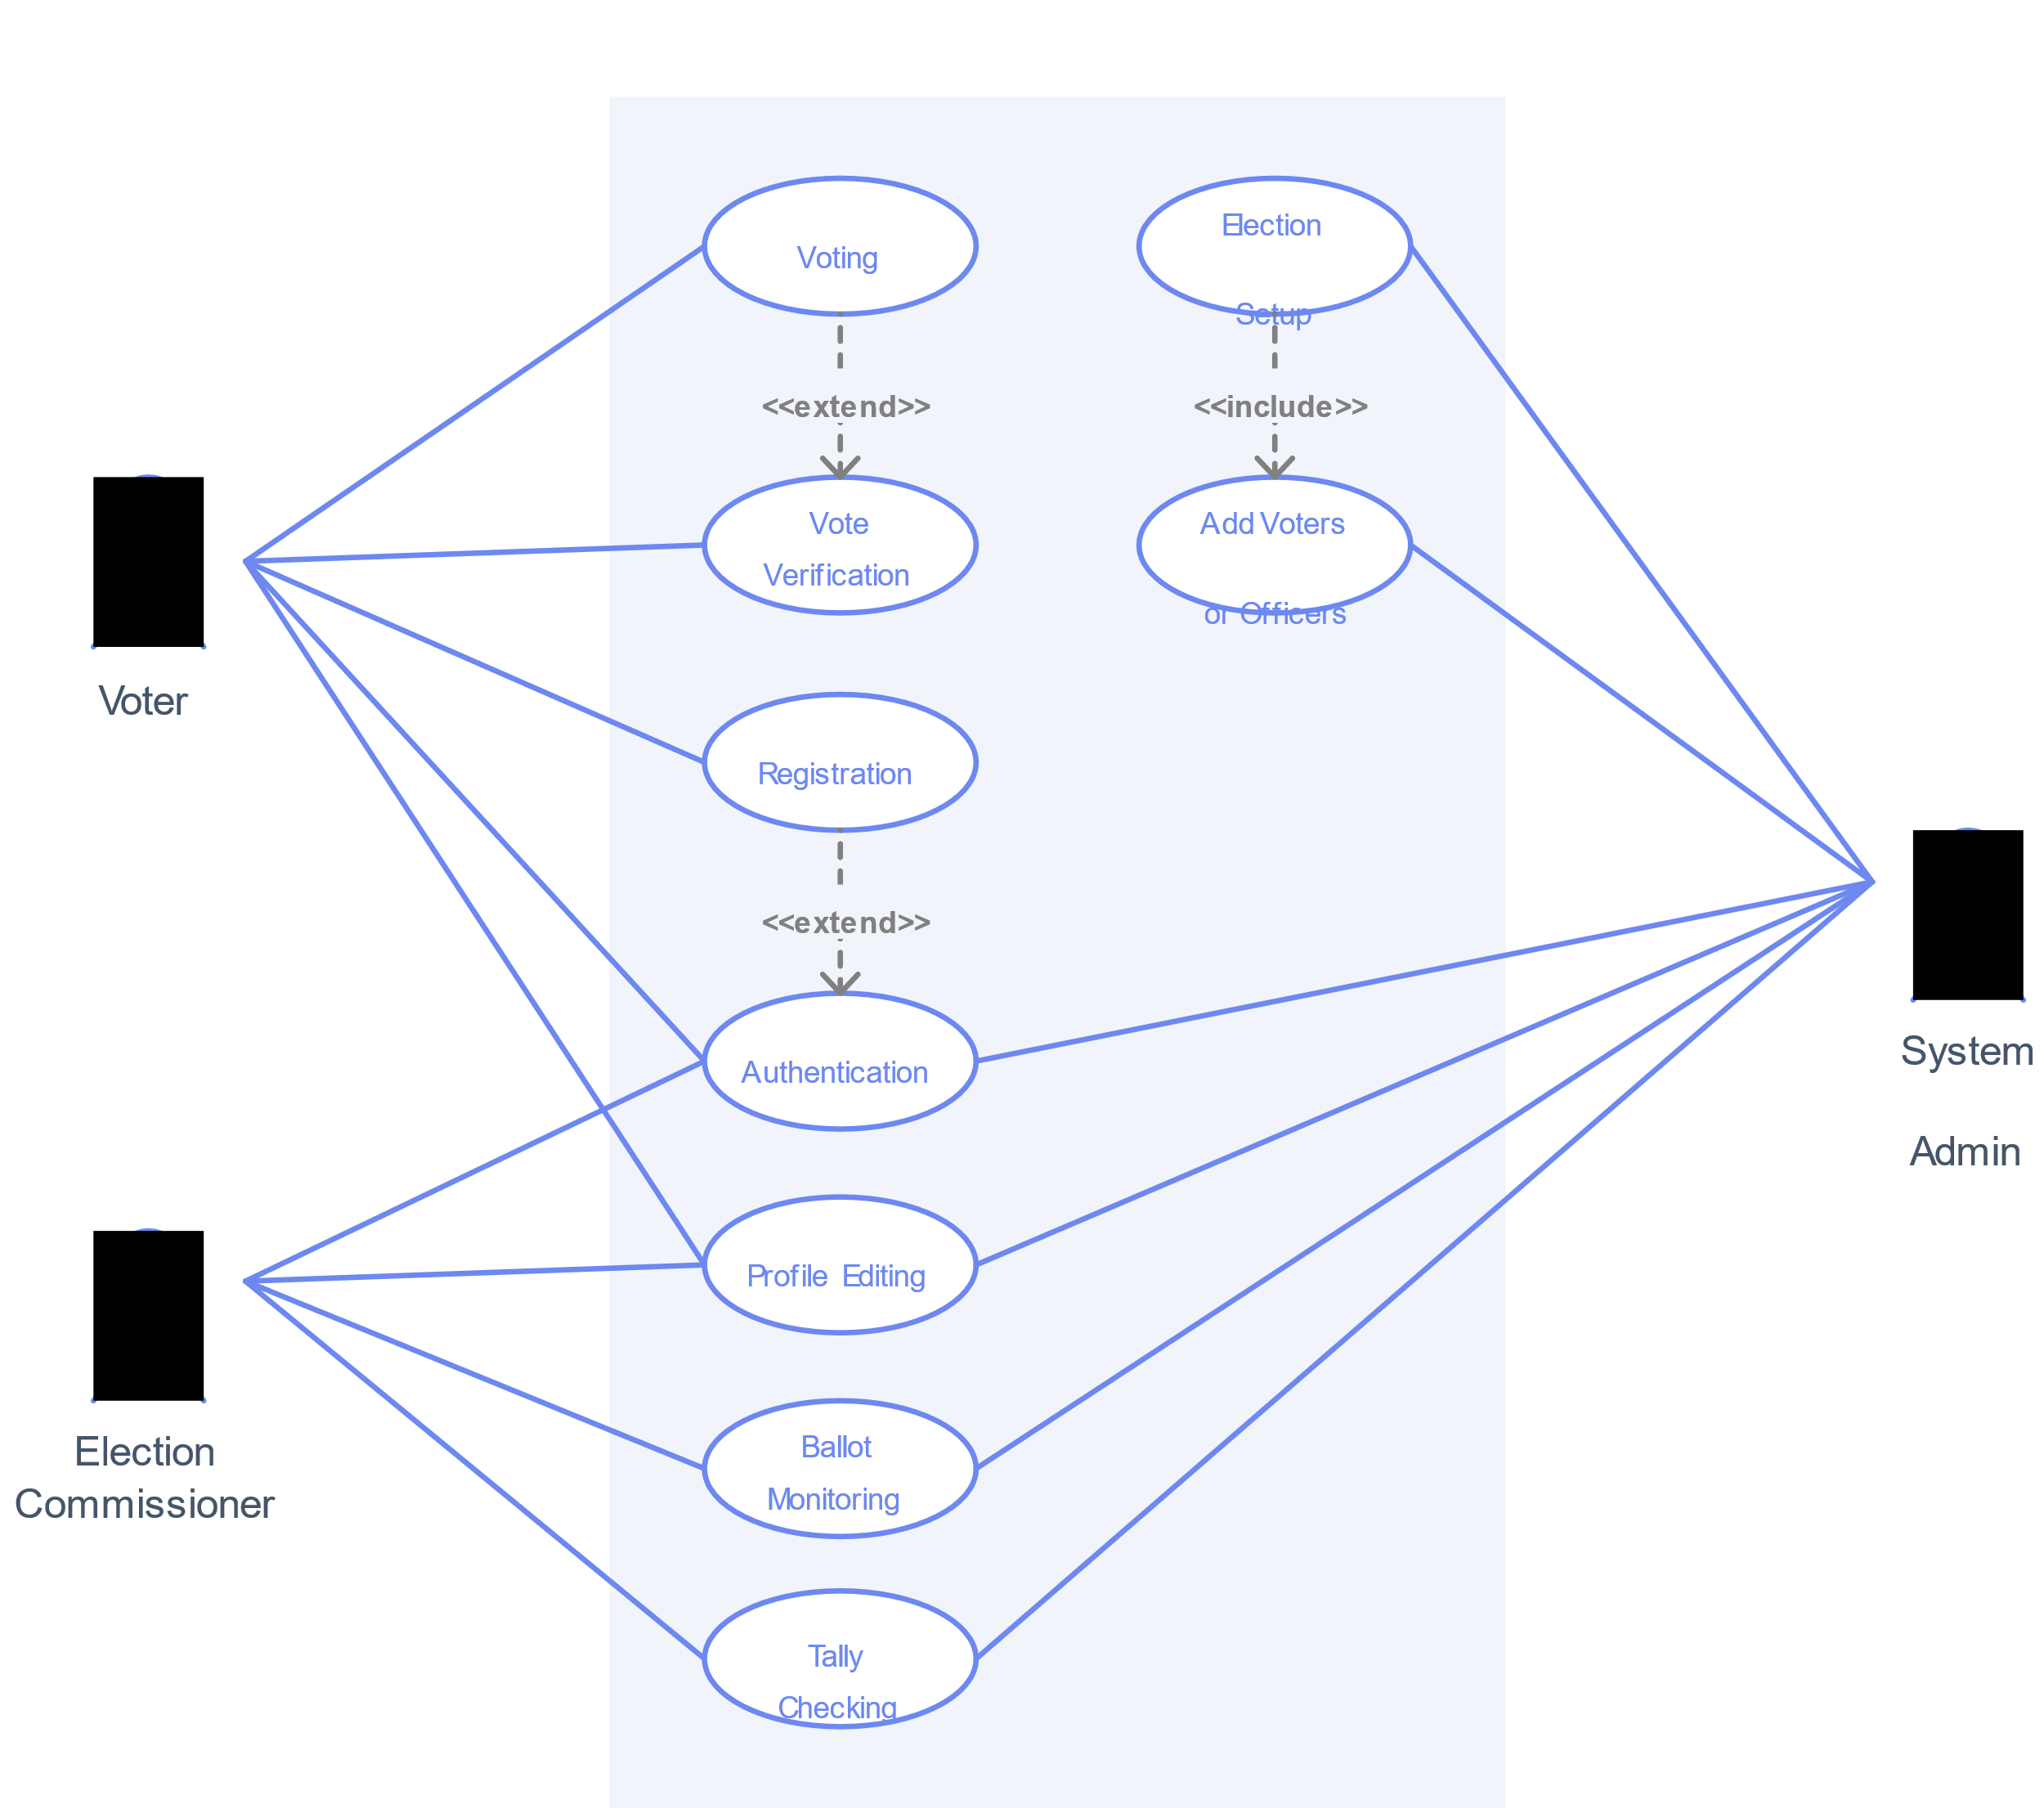

**Output Images:**

